[](http://www.google.com/url?sa=i&rct=j&q=sandpaper&source=images&cd=&cad=rja&docid=l_N4NZOBJbxY-M&tbnid=R5V6oZpaTKvqxM:&ved=0CAUQjRw&url=http://www.samuelkirk.co.uk/sandpaper-sheet-25-grade-50-10064-p.asp&ei=tflLUvmbLonO9QTJiIFo&bvm=bv.53371865,d.eWU&psig=AFQjCNEM1EPsEbZ6wjq_yfJSz1H2cBQSBA&ust=1380797231631277)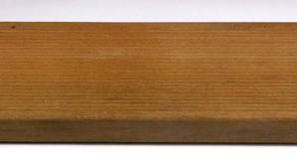Grit

What is **grit**? What does it feel like? Ask the 5thgrade students at Titus who experienced first-hand the true meaning of “**Getting Gritty.”**

Together, we read a story about a lightning bug named Leo. Leo was **determined** to find a way to make himself glow. He **persevered** - he didn’t give up! Leo practiced and practiced and was **determined** to accomplish his goal…and he did!

We got **Gritty** with sand paper and were **determined** to reach our goals. We **persevered** through minutes of hard, perspiring sanding! Did it feel good? NO!. It was *hard*, and *dirty*, and *very tiresome.*!! Did we want to give up, yes! Did we? NO!!!!! And after it was done, we felt ***proud!***

This year, I am **determined** to face **challenges**, **persevere,** and **work hard**!!!

Signature:

**Draw a picture of our sanding activity here:**

Write a caption for your picture. Try to use the describing words we talked about today: